Part A
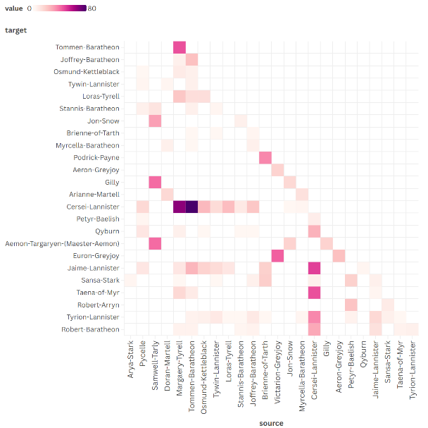
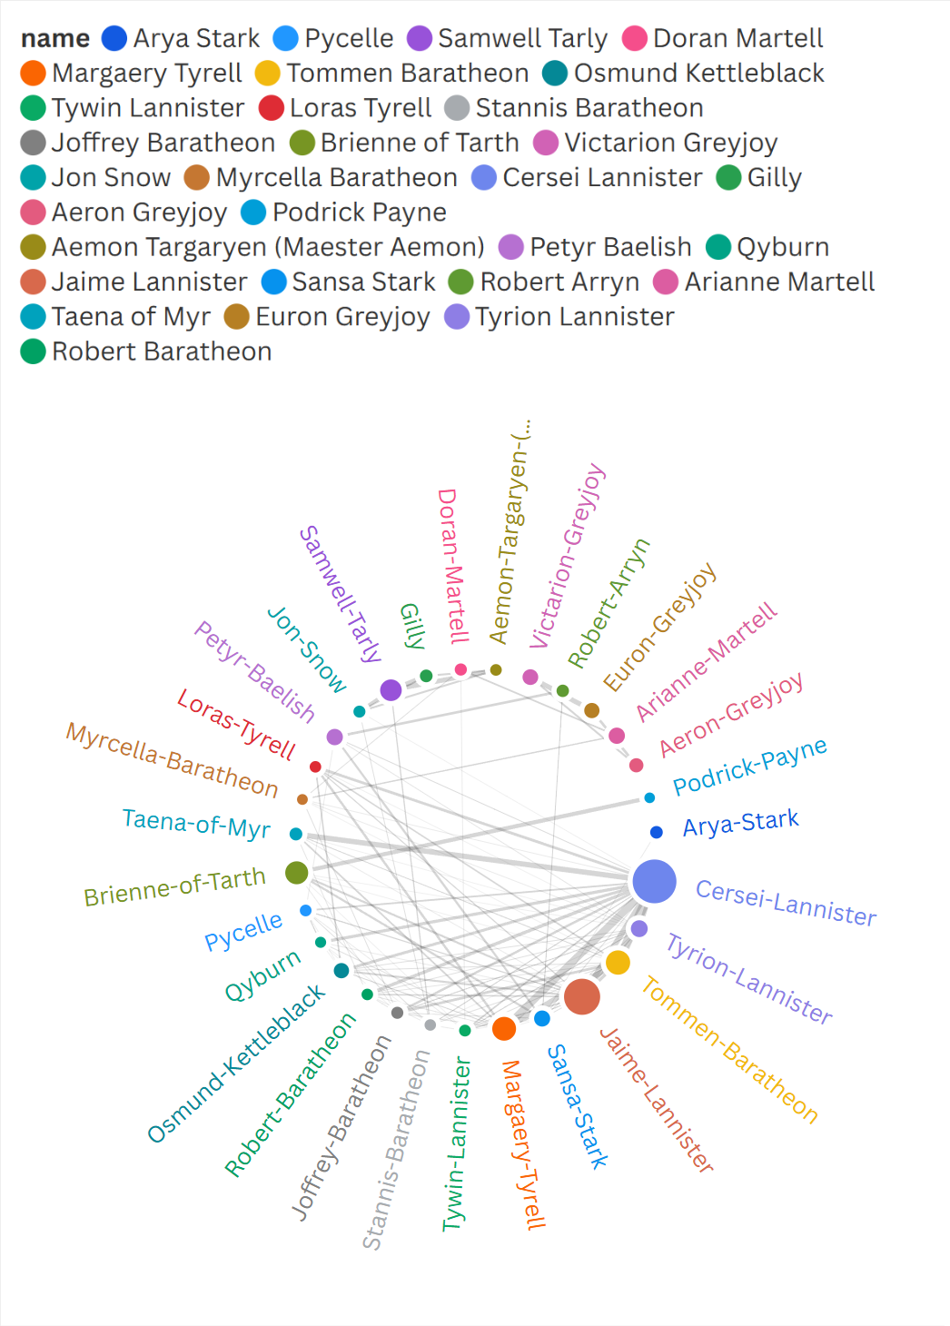

Part B
- A) Cersei Lannister appears to be the most prominent character in this book. The first visualisation has their point as the biggest, showing that they have the most links, and the second.
B) Cersei Lannister and Tommen Baratheon have the highest number of co-occurrences. The second visualisation, the heatmap, made this easier to see.
- The node-link diagram makes it easier to see how often each character has a co-occurrence with another. This is by simply seeing how many link each character has and how big their point is. However, the heatmap makes it easier to see how frequent each character makes a co-occurrence with. The node-link diagram also allows for this, but colour hue is much easier to make comparisons with than size.
- Node-link diagram: It is difficult to see specifically which character makes a co-occurrence with. This can be solved by implementing an algorithm to minimise the amount of link intersections.
Heatmap: It can be difficult to locate the row/column for a character when looking for a particular one. This may be made easier by ordering the characters by alphabetical order.

